**Docker Swarm**

* So far, we have been using a single host with all the containers: It is good for Dev Purposes but not for Production. **Single point of failure**.
  + **If the underlying host fails, we will lose all the containers and our app goes app.**

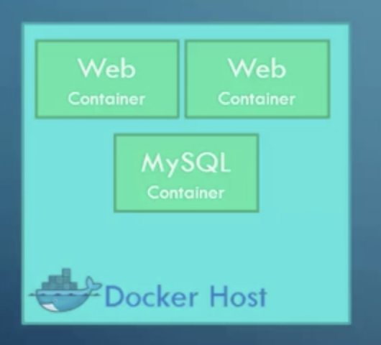

* With **Docker Swarm** you can manage docker multiples machines together as a single cluster.
  + **Hight availability**

* Set up is easy:
  + Must have hosts with Docker installed
  + One host is designated as master (Swarm manager), the rest is called slaves or workers.
  + $ docker swarm init inside the manager.
  + $ docker swarm join inside all nodes or workers.

**Deploy Services**

* Use the same file as before with adding:
* Deploy:

replicas: 5

